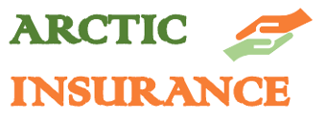
Insurance policy

Insurance company information Policyholder information
Arctic Insurance LTD | Name:
Kulmankuja 5 | Address:
96300 Arctic Valley | Postal code:
Business ID: 3133862-9 | Business ID:
email: arcticvalley00@gmail.com | email:

Insurance

To calculate your insurance offer, fill in the information below as carefully as possible and return the form completed to the insurance company.

Insurance of company assets and activities:

Property insurance | industry | 21€ /month | price
Machine breakage insurance | machinery | 17€ /month | price
Legal expenses insurance | industry | 17€ /month | price
Liability insurance | industry | 33€ /month | price
Vehicle insurance | vehicle | 37€ /month | price
Interruption insurance | industry | 25€ /month | price
Cargo insurance | Value of goods | 50€ /month | price

Statutory insurance:
 | Pension insurance for entrepreneurs, starting entrepreneur | 18,798% | earnings
 | Employer’s employment insurance given to employees | 24,81% | payroll
 | Unemployment insurance | 0,27% | payroll
 | Accident insurance | 0,70% | payroll
 | Group life insurance for employees | 0,06% | payroll

Total price of insurance €/month.

This contract has been made into two (2) copies, with one for the customer and one copy for the service provider.
Time and location:
Customer:
Insurance company:

