Service provider information

Company: Napaleasing
Address: Keskuskatu 7
Postal code: 96200
Postal Office: Arctic Valley
Business ID: 4777627-9
Email: arcticvalley00@gmail.com
e-invoicing addres: 003747776279

Customer information
Company:
Address:
Postal code:
Post Office:
Business ID:
Email:

Product name and model here

Price list:

KM / Year | Price / month (VAT 0%) | Choice
10 000 km | 400 €
30 000 km | 500 €
60 000 km | 600 €

Temporary leasing for the time period of:

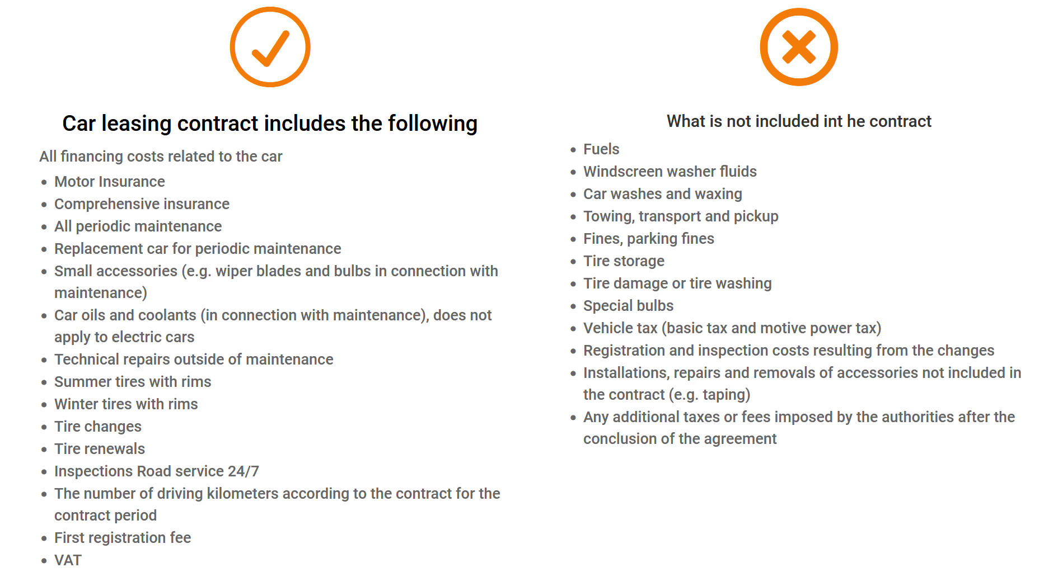

Total price XXX € / month (VAT 0%)
Monthly billing. The bill is delivered on the first day of every month.
Napaleasing delivers the car to the office on the first day of the contract period.

This contract has been made into two (2) copies, one for the customer and one for the service provider.

Date and Place
Service provider | Liisa Laina , Napa Leasing
Customer

